Getting Intuition

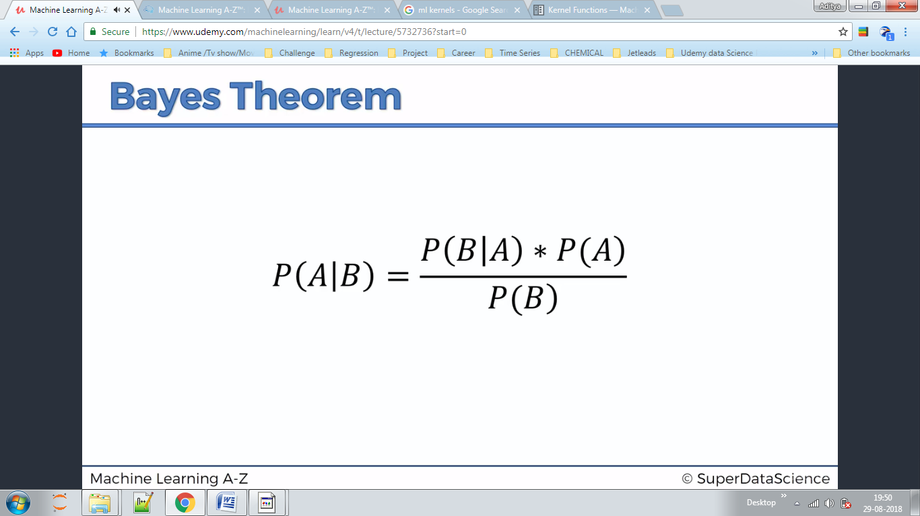

Draw a circle ,with any radius .Anything that is inside circle is deemed to be similar to the point that we added.Here we talk about comparing the probability of a point inside circle being red and the probability of a point inside circle being green

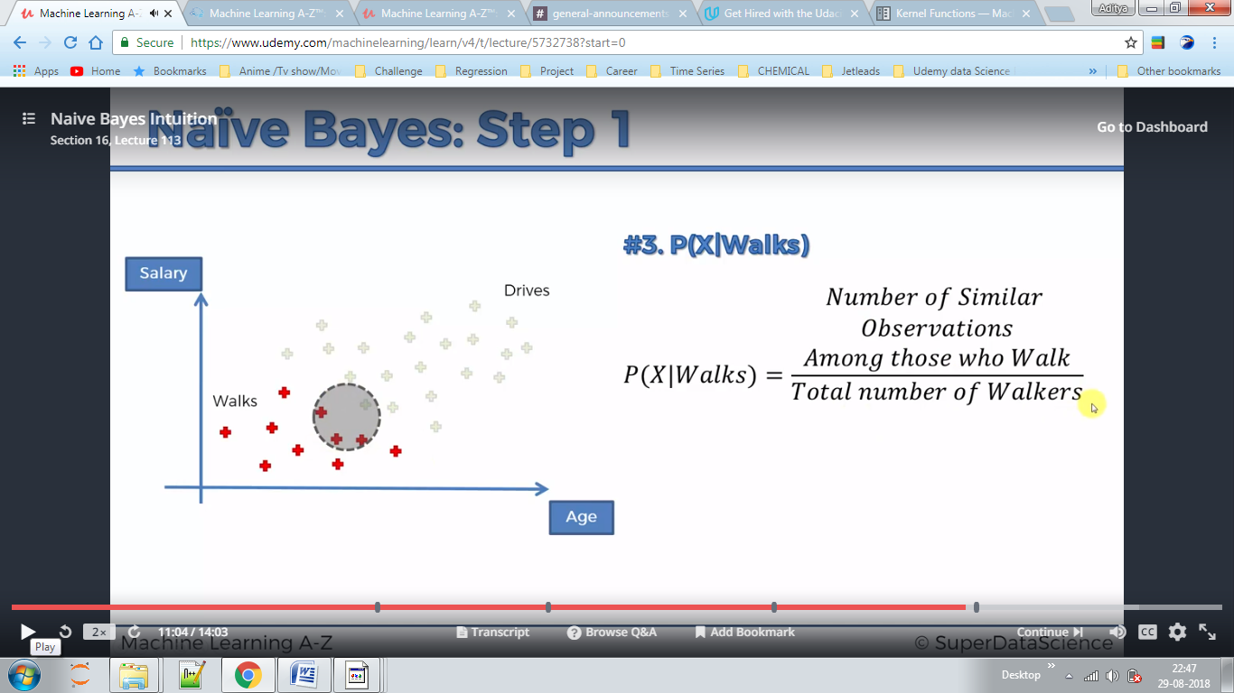

Step 1

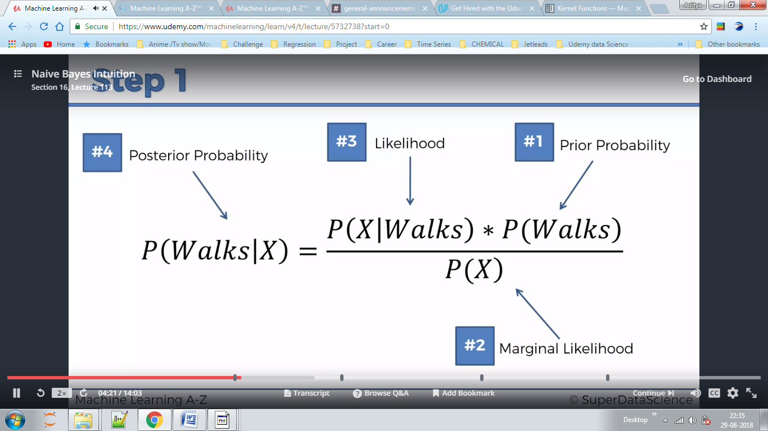

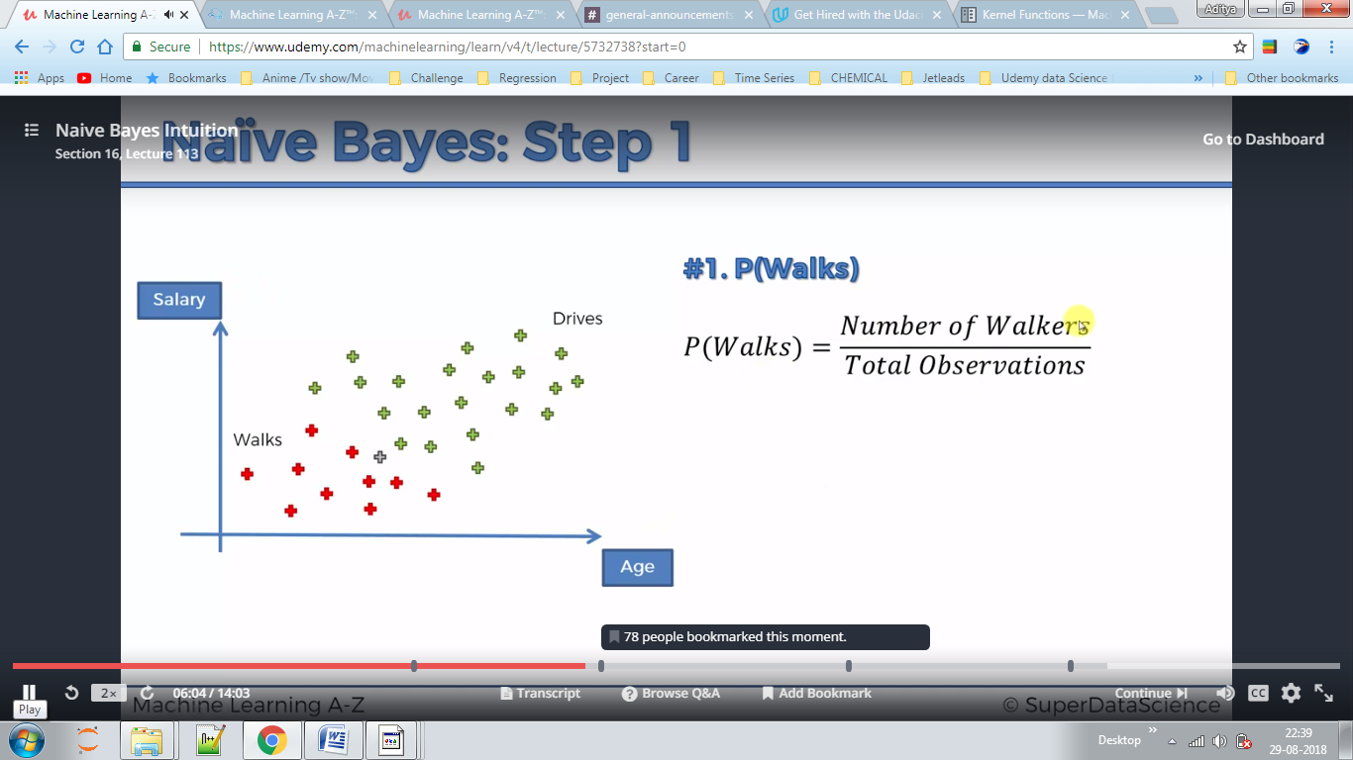

Step 2

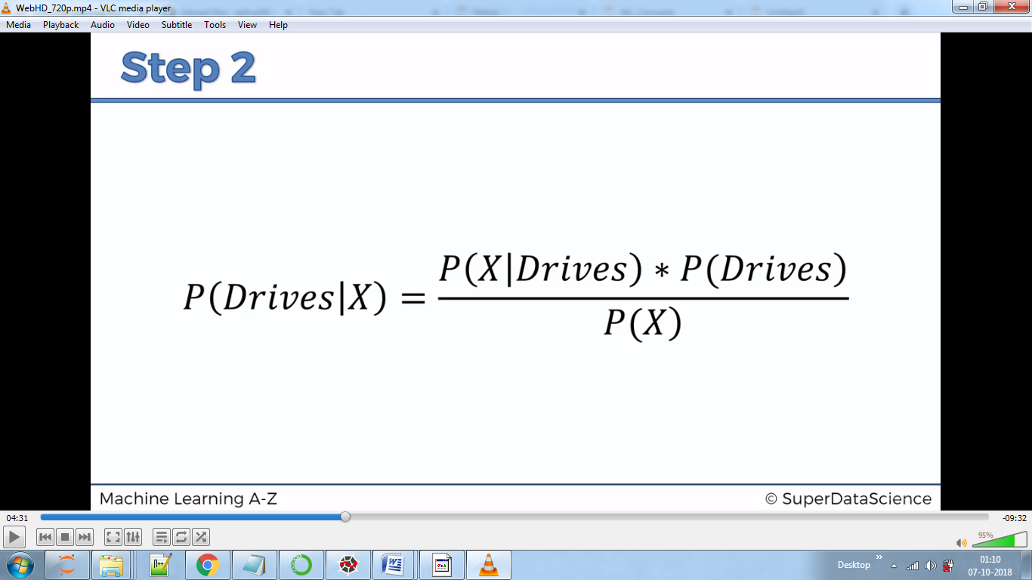

Step 3 Comparing these and assigning the test point to class which is having higher probability.

They are called as Naive because we take assumptions which maybe incorrect.

DRAWBACK

According to Bayes theorem Salary and Age should be completely independent but they may be dependent here.

